SQL LAB QUESTIONS-----
Table 1 creation:
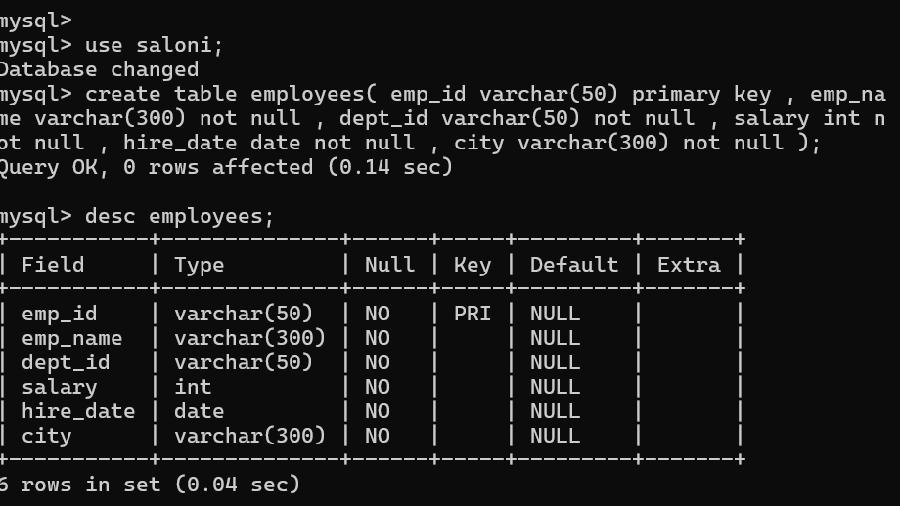

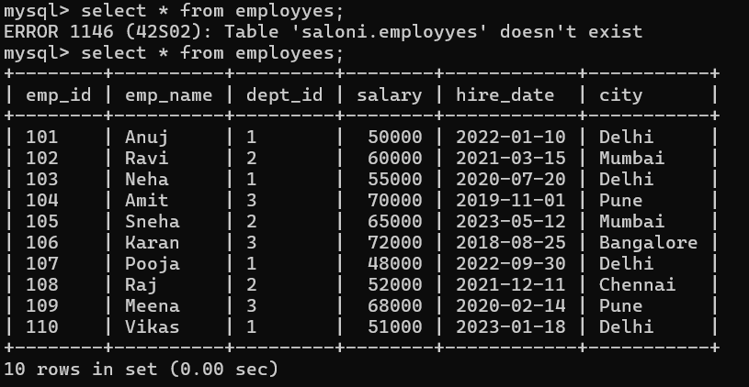

Table 2 Creation:

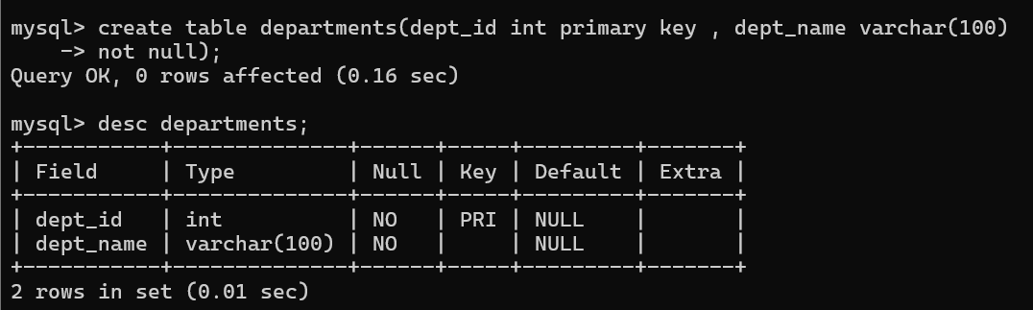

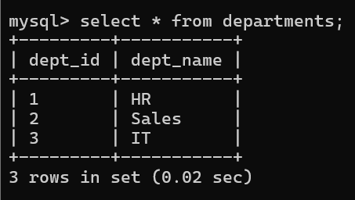

Table 3 Creation:

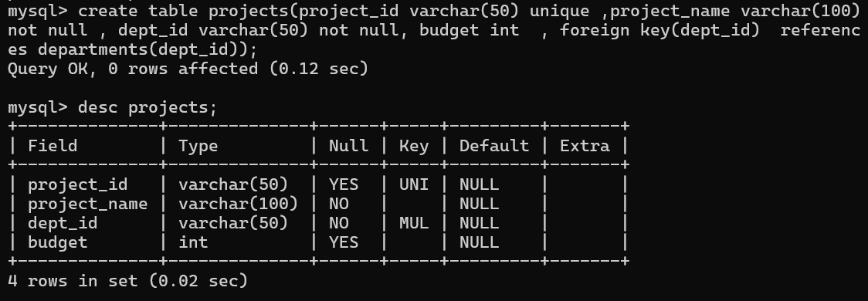

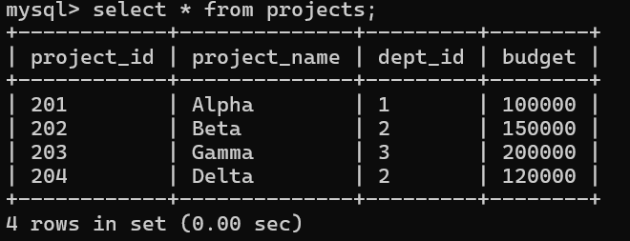

Table4 creation:

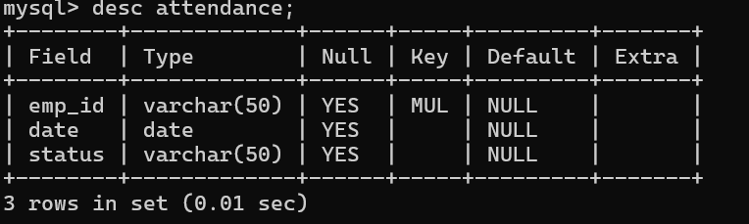

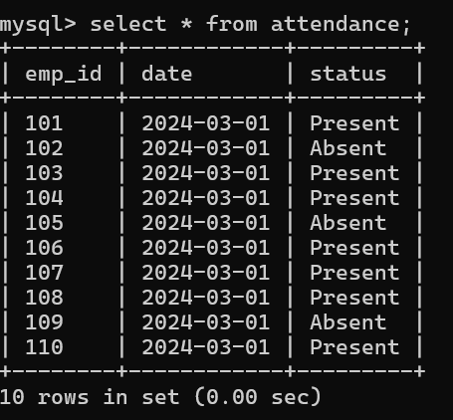
Question---------
- Retrieve all employees.


2.Display only emp_name and salary.
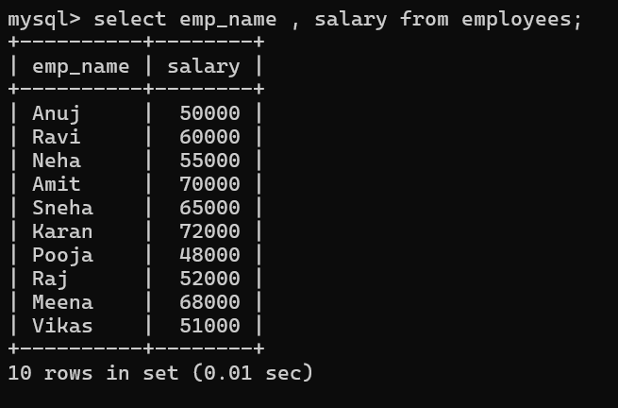
3.Find employees working in department 1.
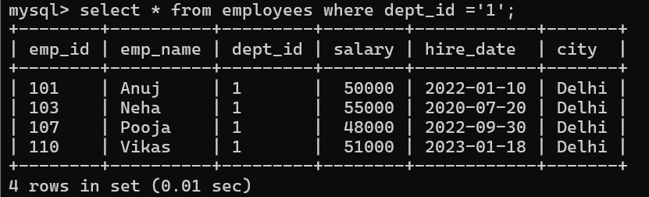
4. List employees from Delhi.
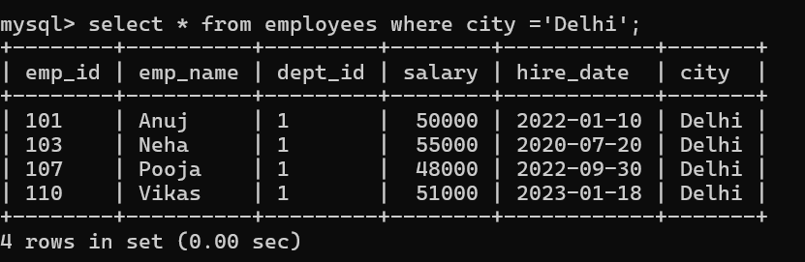

5. Show employees with salary greater than 60000.
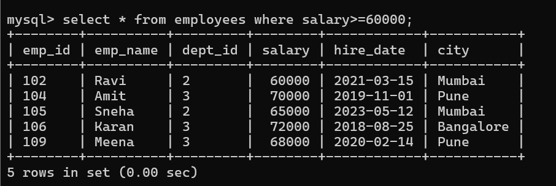

6. Find employees hired after 2021.
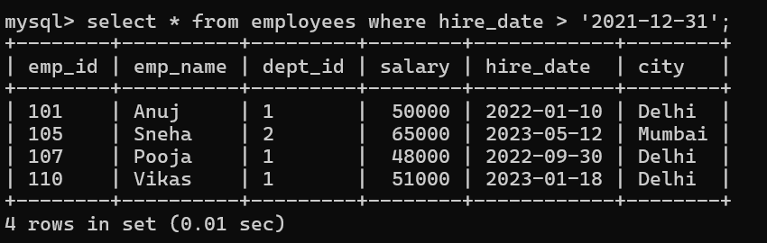
7. Display unique cities.
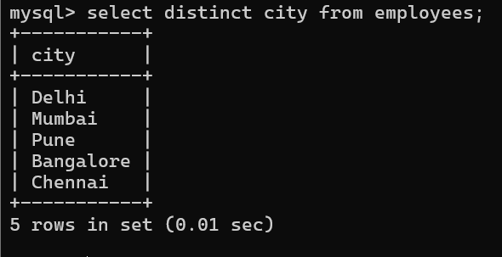
8. Sort employees by salary (descending).
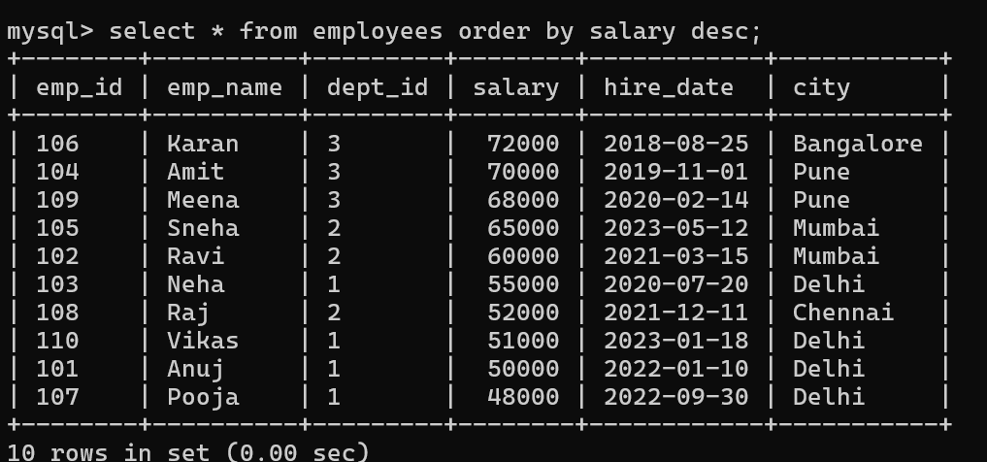
9. Count total employees.
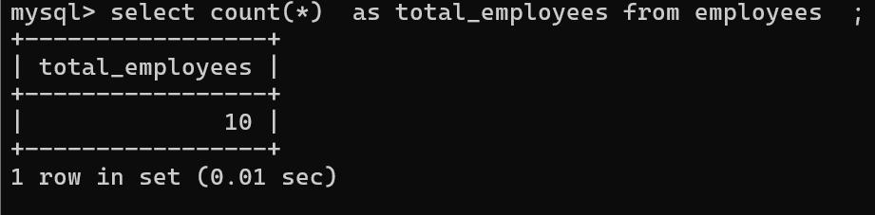
10. Find average salary.
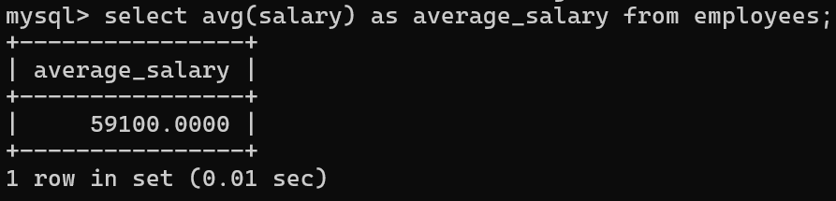
11. Find total salary paid per department.
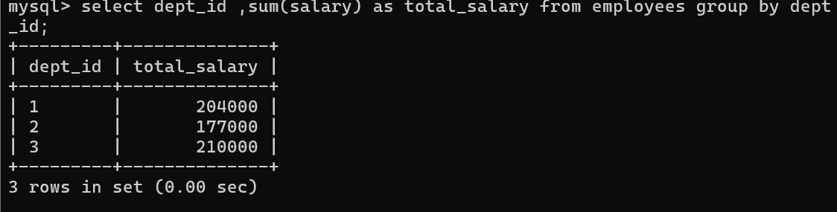
12. Count employees in each department.
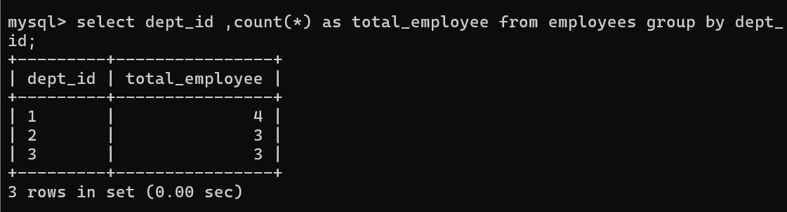

13. Find highest salary in each department.
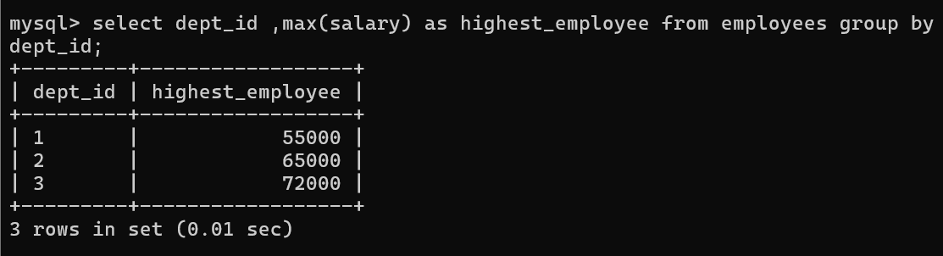
14. Display employees along with department names.
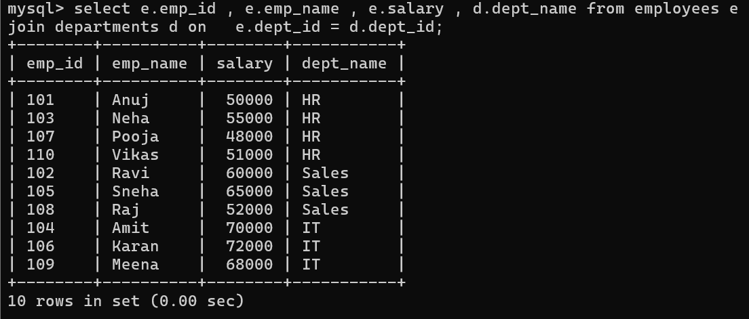
15. List employees working on Sales department.
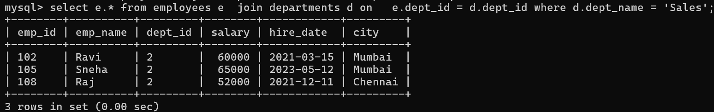
16. Find employees whose name starts with 'A'.
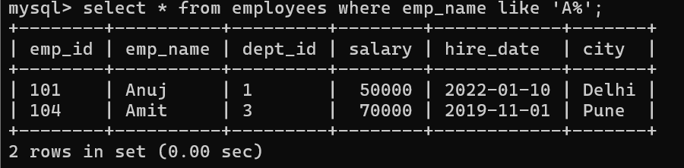

17. Get employees with salary between 50000 and 70000.
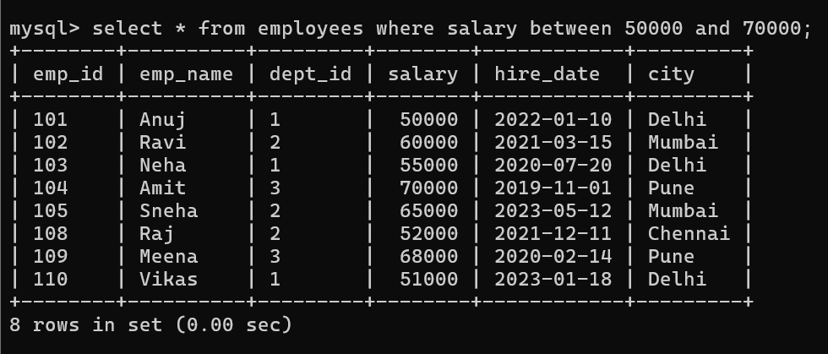
18. Find employees not from Mumbai.
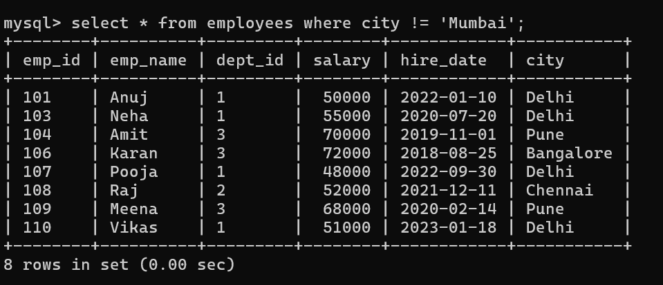
19. Show employees hired in 2022.
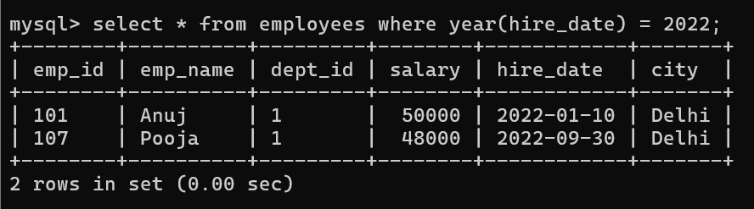

20. Find top 3 highest paid employees.
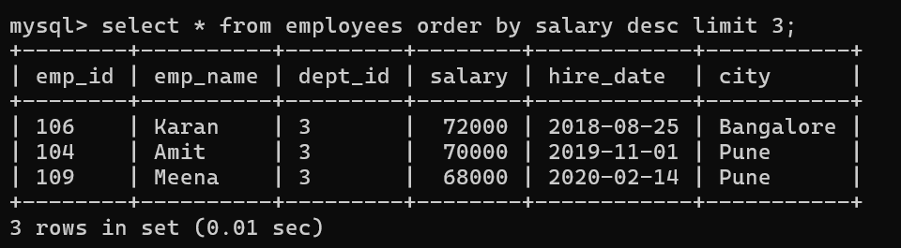
21. INNER JOIN Employees and Departments.
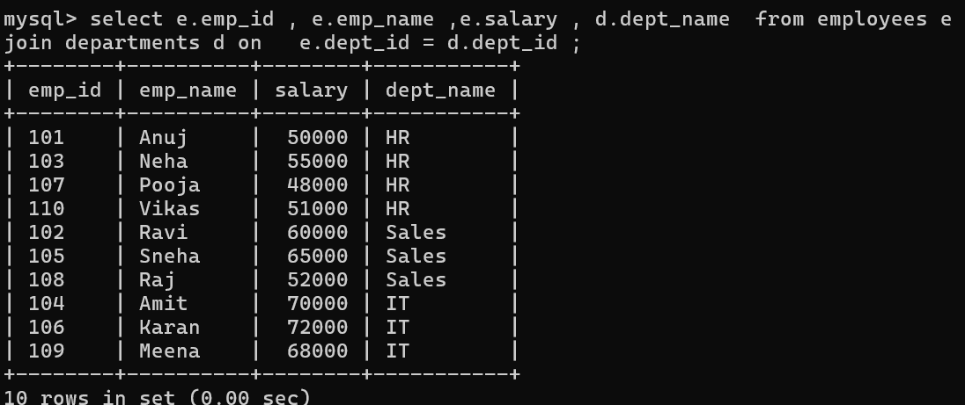
22. LEFT JOIN to show all employees with department names.
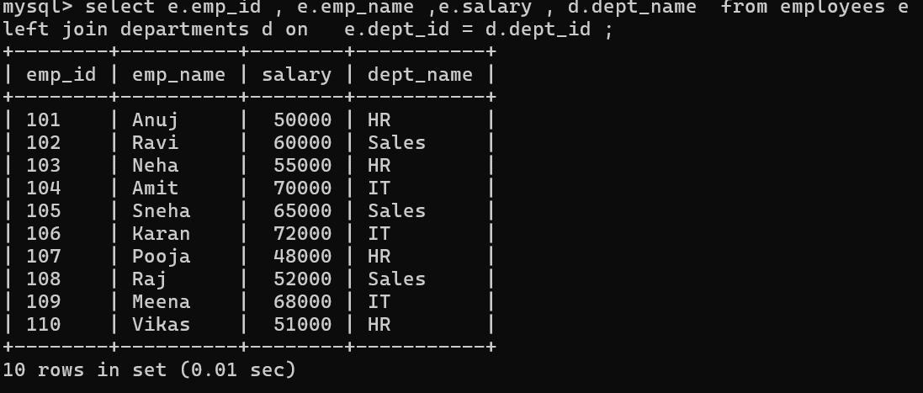

23. Find employees working in IT department.
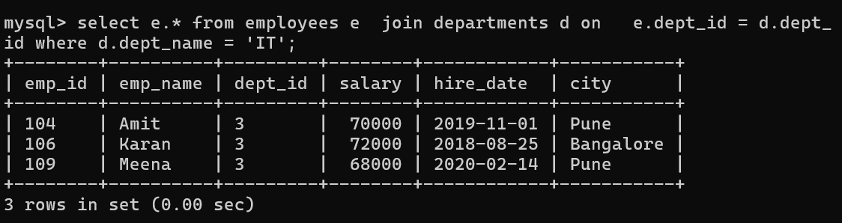
24. Show project names with department names.
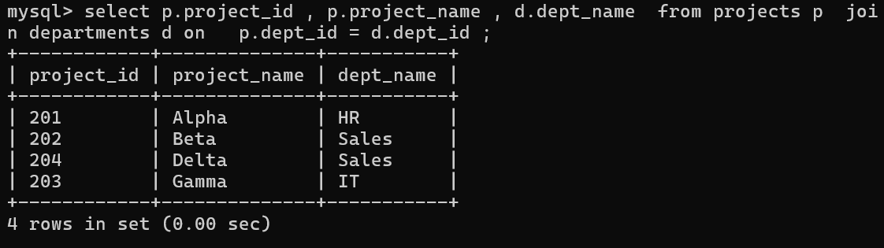
25. Find employees and their project budgets (via department).
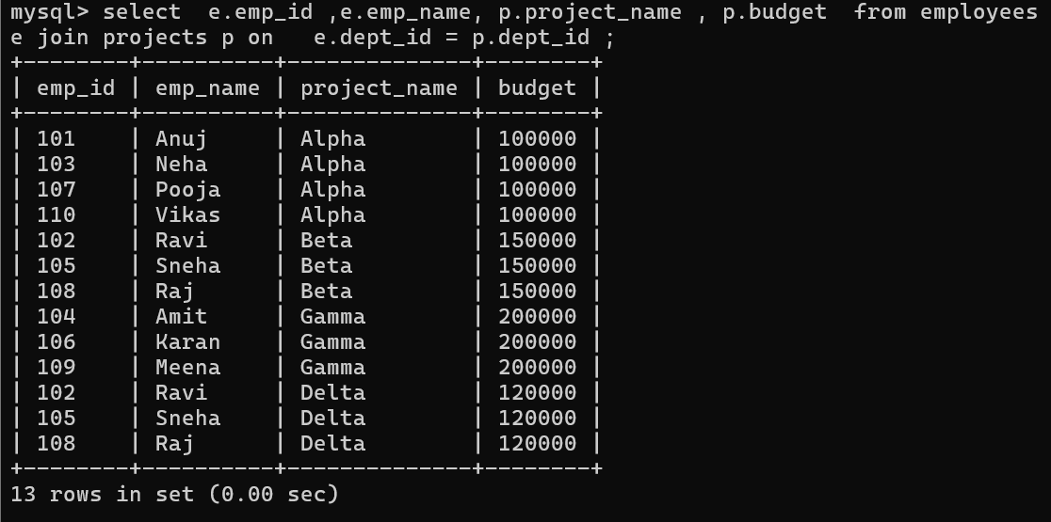

26. Find second highest salary.
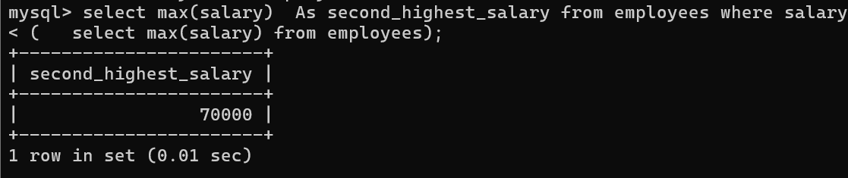
27. Rank employees by salary.
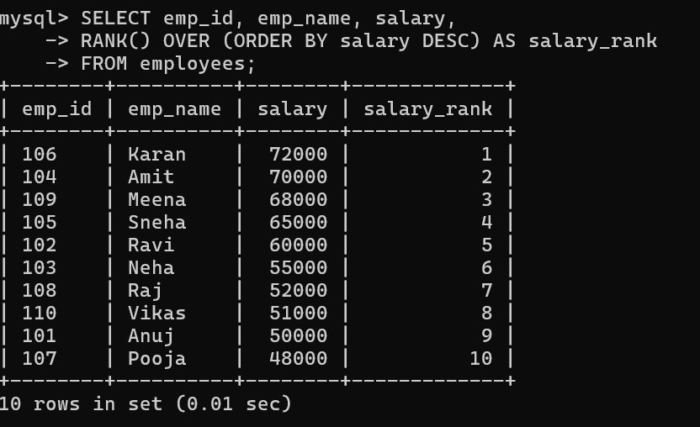
28. Find employees earning above average salary.
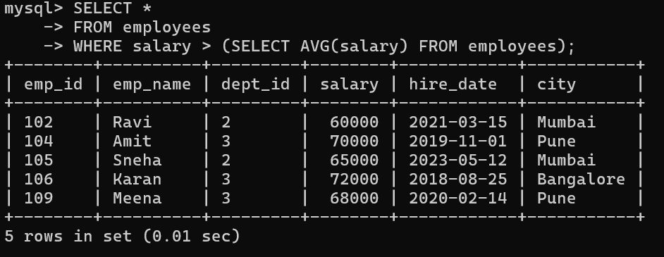

29. Get department with highest total salary.
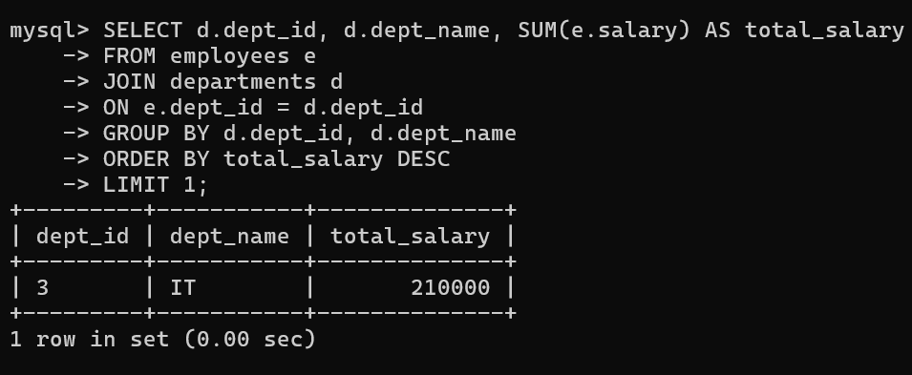
30. Find employees who were absent on 2024-03-01.
